Student Name: Rama Mathur
Cohort #52

1. Problem Statement & Hypothesis
Anyone who has led a product knows the job is largely about persuasion. Product Managers rarely have direct authority over the people they need to influence. Their ideas only travel as far as they can explain them.
And that's where even good Product Managers sometimes struggle.
They understand the problem, know their customers, and have the data to support their decisions. But when faced with unexpected questions, challenging stakeholders, or time-constrained presentations, they sometimes struggle to structure their thoughts and articulate their ideas clearly.
Knowing what to say and being able to articulate it effectively are two different skills.
PMs prepare notes, rehearse presentations, and seek feedback from colleagues. Yet communicating clearly and confidently, especially under pressure, remains challenging.
When the message doesn't land, even well-thought-out ideas can be misunderstood, overlooked, or fail to gain stakeholder support.

1.1 Initial Problem Hypothesis
I believe some Product Managers struggle to articulate their ideas effectively, not necessarily because they lack product knowledge, but because they find it difficult to organize and express their thoughts under pressure.
Hypothesis is that limited opportunities for realistic communication practice and timely, constructive feedback contribute to this gap.

2. User Segmentation

User Segment | Target Users | Primary Communication Challenges | Key Needs | Priority
Working Product Managers | PMs, Senior PMs, Lead PMs | Difficulty articulating ideas, explaining decisions, handling unexpected stakeholder questions | Structured thinking, realistic rehearsal, personalized feedback, guided practice | P0 — MVP
Aspiring & Early-Career PMs | Aspiring PMs, APMs, Associate PMs | Explaining product thinking, interview responses, communicating confidently | Communication frameworks, mock scenarios, feedback | P1
Cross-Functional Professionals | Product Owners, Business Analysts, UX Designers, Engineers | Explaining complex ideas, influencing stakeholders, presenting recommendations | Role-specific practice, clear messaging, audience-aware communication | P2
People Managers & Leaders | Engineering Managers, Directors, Business Leaders | Executive communication, storytelling, persuasion, difficult conversations | Leadership communication coaching, strategic messaging | P3
Students & Early-Career Professionals | College students, graduates, job seekers | Public speaking, interviews, presenting ideas, confidence | Foundational communication coaching, practice, constructive feedback | Future
General Professionals & Individuals | Professionals and adults seeking communication improvement | Everyday conversations, presentations, networking, storytelling | Personalized communication development | Future

3. User Research

User Name | User Role | Can you recall a recent situation where you struggled to clearly communicate your ideas during a meeting or presentation? What happened? | How did you prepare for that situation, and what do you currently do to improve your communication skills? | When was the last time you received feedback on your communication, and what did you do with it?
Ravi Jakkuva | Product Owner | Usually while presenting, the biggest pressure for me was how others perceive it? And so I falter during presentations. | I am doing a pre presentation demo with my colleagues before going live. | My colleagues gave me some feedback on where I was going wrong. I started consciously working towards resolving it by better preparing myself
Manav Yadav | Aspiring Product Manager | During my research paper presentation, I felt a bit nervous and struggled to explain my topic clearly. I knew the content, but I couldn’t express my thoughts as clearly as I wanted to. I tried to stay calm and keep my focus on the topic so I could continue. | I prepared by reviewing my paper and practising how I would explain it. To improve my communication, I read books, listen to podcasts, and practise with people I know. Sometimes I recreate a past situation and try explaining it better, or rehearse for an upcoming presentation. | The last time I received feedback on my communication was after a presentation. I noted down the feedback and tried to apply it during a later presentation. Practising those points helps me work on the areas where I struggled.
Nikhil Bhere | Product Manager | ⁠The most recent one is presentation for assignment 2, although I had prepared little for the presentation, I somehow gave the presentation which went over time limit, had a lot of fillers ( I analysed the recording later) but the most important thing was the tutor for the assignment gave me feedback about a particular feature, which I had indeed included in the assignment mvp but as I couldn’t articulate it properly it didn’t reach her, so it was kind of disappointing presentation from my point of view and could have done better I think | To improve my communication skills, one is active learning like watching podcast reading, another is nowadays try to strike conversation with strangers around me in different situations, also when talking to people trying to explain a topic I introspect in between if I am going too fast or slow, if opposite person is listening well, but don’t get much opportunity to practice long conversations | Honestly, even when I ask people don’t provide honest feedback even when I am open to it, either they are too nice to say it out loud or I am good by their standard, but I consider myself fairly good communicator but I do want to improve more both in formal and informal situations.
Rashika | Product Manager | So, the first thing I recall is, I was trying to present a retrospective, and, you know, I had information, but it felt overwhelming, and I was trying to... you know, I was not able to clearly articulate it well and was not able to answer much of the questions that they had asked. | So, the first thing I recall is, I was trying to present a retrospective, and, you know, I had information, but it felt overwhelming, and I was trying to... you know, I was not able to clearly articulate it well and was not able to answer much of the questions that they had asked. | I have never, you know, got feedback about my communication, but I felt like I wanted to improve much because when I talk, it will sound confident enough, but I know what I am talking and what I am trying to convey because somewhere I feel, you know, I'm not able to communicate what I feel like.  So, but somehow it will reach out to the person whom I'm talking to. So that's not a big deal. I have not got any feedback on that.  But the problem is, when you know this is a real struggle and you're trying to improvise, that's where I started to, you know, put pen and paper before talking to someone so that, you know, it helped me better to clearly speak about those points without missing details.
Akshay | Associate Product Manager | While creating and preparing short notes to keep in mind. Lack of Fluency is the main cause while communicating, that leads to forgetting something. | Just moving in a natural flow without improving | Haven't received any feedback
Hema | Product Manager | I had a mid-year review discussion on 14-Oct with my boss who's an MD and I wasn't prepared for a question he asked me on my vision for a certain new activity in the org. I had some great ideas for that but since I wasn't prepared with a properly framed answer I ended up giving him an unstructured brain dump that he responded to by saying "I am not sure what you just said but I got a gist of it" - that was really embarrassing. | I wasnt prepared for that Q - but I was very prepared for the conversation and its agenda by sending pre-reads, links resources needed for a productive conversation. But after that incident I watched quite a lot of youtube videos to see how I could have dealt with such an unexpected loaded question and picked up a few frameworks that I am trying to incorporate in all my communications for regular practice. | This incident was the latest feedback but normally I have received a feedback of being a good communicator but I need to slow down is what I've heard from my bosses abt 5+ years back
Yezi | Product Manager | Not a problem with AI tools. They help with content and structure.  Asynchronous communication, slack instant messages.  Not sure if I am well expressed in those messages.  Not much context and dealing with several tasks.  I don't want to write long messages.  Instant and short communication is the primary concern due to lack of context.  I am concerned about asking basic questions to people who can help me with this situation. | Be transparent, proactive and use AI tools. Prepare and plan for planned communication.  Have guidelines.  Ask questions before assuming things. Pay attention to details. | Yes  Received great feedback sometimes. Sometimes they said, don’t send messages, just call.  Be transparent, proactive, anticipate other communication needs.
Sonesh | Product Manager | Yes it was when I was suggesting a new feature for the logistics shipping platform for having weather based predictions for the shipments and communicating early to the customers to have good customer experience to retain the customers. The idea is superb but the struggle was about implementation flow and how which I cannot articulate clearly | To prepare for that situation, deep research and customer journey mapping and data points need to be established between the internal systems which comes only after you practise writing your ideas into structured format and go for presentation which I am improving | In recent Hackathon and I have started preparing to make a flow of everything before simply articulating
Sumit | Product Manager | In a AI weekly meetup in out organization, I was giving demo on google collab, but during this preparation I was trying the demo multiple times resulted in the processing limit exhaust, during demo I realized that the steps I am trying to run not working, to overcome this situation I have some opened the text where I have copied previous execution result and then I continue with that. | First part I have already mentioned above, for improve communication skills I am trying to increase my vocabulary by reading books | I have never get feedback for communication as I have most of the discussion on tech topics.
Varun | Business Analyst | I have never get feedback for communication as I have most of the discussion on tech topics. | As a Business Analyst by profession, Communication is key strength for me.I do follow communication coaches on Instagram and watch youtube videos to enhance my communication skills. | ⁠It was before 2 years back, I received constructive feedback from my manager, then I enrolled into internal courses to improve my communication skills.
Narasimha | UX Designer | Recently, I presented a new dashboard design to my team. I had a clear idea of how to improve the user experience, but when I explained it, I focused more on the visual changes than on why they were important. The developers and product manager didn't fully understand my reasoning, and the discussion went in a different direction. I struggled to explain the business impact of my design decisions. | I usually prepare the design and collect references before the meeting, but I don't always prepare how to explain my thinking. Now, I try to write down the main problem, my proposed solution, and its benefits before presenting. Sometimes, I practice explaining the idea to a colleague first. | During a recent design review, my manager told me that my presentation was visually good but needed a clearer explanation of the problem we were solving. Since then, I've started explaining the user problem first and showing the design afterward.
Charith | Product Manager | 6 months back i was preparing for a GTM interview for which i created a pitch deck. I practiced everything but I couldn’t articulate it well. Eventhough i cracked that interview, it could have been a lot better if i were able to put out everything i prepared for | I didn’t prepare seperatly for communication. The main problem is I couldn’t recall those terms and subject related . I can communicate well if i understand the context and the content better | I dont use any but now i am planning to use notebook LM to practice  Because of subject matter expertise to articulate i must know the concepts right  I use chatgpt or claude to ask me few questions about my topic before going to the interview  I save so many public speaking videos on Instagram only for to not look at them ever again
Manisha | Product Manager | Recently, during a work discussion, I had some ideas and suggestions but found it difficult to explain them clearly and in a structured way. I knew what I wanted to say, but I struggled to put my thoughts into simple structured words, so others could easily understand my point. | I usually prepare by thinking about the key points I want to discuss. Sometimes, I write them down before a meeting. I am also trying to improve by practising how to explain my ideas in simple words, observing how others communicate, and using tools like ChatGPT, Gemini to organise my thoughts. | Recently, I realised that I need to be more clear and structured while explaining my ideas. I am working on this by focusing on the main message first, giving specific examples, and avoiding too much detail at once. I believe regular practice and feedback will help me become more confident.
Chimay Sandur | Product Manager | The common situation would be when I am giving some interview or when I know the stakes are high I sometimes feel nervous. But after a few minutes Into the conversation if the conversation is going smoothly I wouldn't be nervous. | If I know before hand what the conversation I am going to have, I would articulate the thoughts and points I am going to have the conversation on. Regarding how I would improve it — I often practice with mirror or camera in front of me. | I have never been into a situation where I would receive the feedback on my conversation.

4 User Research Insights

Theme | Details | #Users | Root Cause | Prioritization
Difficulty articulating ideas | Most of the PMs know what to communicate but struggle to articulate their thoughts | 9 | Due to more focus on what to present rather than how to deliver the presentation.  No practice, no honest feedback channel to refine. | P0
Forgets what to communicate | PMs goes blank during presenting their ideas, stories and trade-offs | 1 | Memorizes the information rather than understanding the concept and building mental models around it. | P1
Fear of judgement | In presentations PMs lose track of what they communicate due to fear of judgement | 1 | The fear of being judged is real, and there’s rarely a safe place to practice, so the first real run-through happens in front of the people whose opinion matters most. | P2
Failed to anticipate communication needs | PMs sometimes struggle to anticipate communication modes (short text, long text, calls, emails) | 1 | Little shared context and no guidelines. Async, instant messages with several tasks in play lead to under-explaining, and some people hesitate to ask basic questions. | P3

5. P0 Problem Statement
Product Managers struggle to structure and articulate their ideas and decisions clearly, especially during presentations and unexpected stakeholder conversations.

5.1 Rationale for P0 Selection
I selected articulation as our P0 problem based on the following findings:
- Recurring problem: 9 out of 14 participants interviewed described articulation-related challenges, making it the most frequently identified theme in our research.
- Meaningful impact: Users shared instances where their ideas were misunderstood, important information was missed, or they struggled to respond to stakeholder questions despite understanding the subject.
- Opportunity for improvement: The research highlighted potential contributing factors such as difficulty organizing thoughts under pressure, limited realistic practice, and inconsistent actionable feedback.
- MVP feasibility: Articulation can be assessed through clarity, structure, and conciseness, allowing us to test whether targeted coaching and practice improve how users communicate.
Decision: Prioritize helping Product Managers articulate their ideas clearly and effectively before expanding into broader communication challenges such as presentation anxiety, storytelling, and written communication.

6. Market Research & Competitive Analysis

6.1 Market Opportunity
Product Management requires influencing decisions without always having direct authority. But influence begins with communicating an idea clearly.
Our initial research with 12 participants found that 8 reported articulation-related challenges, particularly when explaining product ideas, recommendations, and reasoning.
Core insight: Product Managers may understand a problem and know what they want to recommend, yet struggle to communicate their thinking in a way stakeholders can easily understand.
Product Focus estimated approximately 1.62 million PMs globally, including 110,000 in India, using October 2023 LinkedIn data. This indicates a potential audience, not a validated addressable market.
Opportunity: Address a foundational PM communication skill—clearly articulating product thinking and decisions—before expanding into broader influence and negotiation capabilities.

6.2 Competitive Landscape

Solution | Primary Focus | MyCommPal's Position
PM Coach | Broad stakeholder communication, executive framing, negotiation, influence, and data-driven argumentation | Focus deeply on diagnosing and improving the clarity of product decision explanations
Second Order | Rehearsing realistic, high-pressure PM conversations with stakeholder pushback | Help users strengthen their underlying message through assessment, targeted coaching, and retry
Yoodli | Communication practice, roleplay, customizable evaluation, and performance improvement | Provide a ready-made PM decision-communication rubric
ChatGPT / Claude | Flexible AI coaching, feedback, rewriting, and roleplay | Deliver a guided, purpose-built improvement journey without requiring users to design prompts
Human coaching / peers | Personalized advice, rehearsal, and feedback | Provide accessible, repeatable, on-demand practice
Competitive insight: These solutions can improve articulation. MyCommPal does not claim that capability is exclusive. It specializes in making product decision communication the central coaching objective.

6.3 Key Market Insights

Market Insight | Product Implication
Stakeholder influence depends partly on clear communication. | Prioritize articulation as a foundational skill.
PM-specific roleplay and communication coaching already exist. | Differentiate through depth of diagnosis, not the availability of AI coaching.
A polished delivery can still contain unclear reasoning. | Evaluate the decision, supporting evidence, trade-offs, and expected impact.
Generic AI tools can provide similar feedback when prompted well. | Reduce prompting effort with a structured, ready-to-use experience.
Feedback alone does not guarantee improvement. | Connect diagnosis to one technique, immediate practice, and a consistent comparison.

6.4 Market Gap & Differentiation Hypothesis
Market gap hypothesis: There is an opportunity for an articulation-first coaching experience that helps PMs improve the clarity of their product reasoning before practicing broader stakeholder influence and objection handling.
MyCommPal is designed around three differentiators:
1. Diagnose the foundational communication gap
Vira evaluates core articulation skills—clarity, structure, and conciseness—alongside PM-specific dimensions when relevant:
- Decision clarity
- Supporting evidence
- Trade-off articulation
- Customer or business impact
2. Coach the specific weakness
Vira identifies one high-impact improvement, recommends a relevant communication technique, and uses evidence from the user's actual response without inventing supporting facts.
3. Turn feedback into observable practice
The user retries the scenario, and MyCommPal compares attempts to identify improvements, unchanged areas, and regressions.
Core differentiation: MyCommPal is designed to strengthen how PMs articulate product decisions, creating a clearer foundation for stakeholder influence and challenging conversations.

6.5 Competitive Advantage — What We Believe
PM Coach and Second Order address broad PM communication and high-pressure rehearsal.
MyCommPal takes a narrower approach: before practicing how to defend a decision against challenging stakeholders, help the PM clearly communicate what that decision is and why it makes sense.
This represents a deliberate product specialization, not a claim that competitors lack articulation coaching.
Our hypothesis is that a focused, evidence-grounded improvement loop can deliver more actionable feedback with less user effort than broader coaching experiences.

6.6 Market Research Conclusion
The opportunity is not to build another AI communication coach. It is to focus on a foundational PM communication problem: the gap between knowing what to communicate and articulating it effectively.
MyCommPal addresses this through Product Decision Communication Intelligence, personalized coaching, and guided practice.
Our product belief: Clear articulation strengthens the foundation for stakeholder influence, alignment, and difficult conversations.
The next step is to validate whether MyCommPal helps PMs improve this skill more effectively or efficiently than existing alternatives.

6.7 What Remains to Be Validated
- Do PMs demonstrate measurable improvement in decision articulation after Vira's coaching?
- Is MyCommPal's focused diagnosis more actionable than feedback from existing AI coaching products?
- Can PMs transfer their learning to unfamiliar product decisions?
- Do users return before important stakeholder conversations, and are they willing to pay?

7. Solution Hypothesis & MVP Definition

7.1 Solution Hypothesis
Product Managers often understand their product decisions but struggle to articulate the reasoning, evidence, trade-offs, and expected impact clearly, especially under pressure.
Our hypothesis: If PMs receive precise, evidence-based feedback on their communication gaps, learn a targeted technique, and practice immediately, they can articulate product decisions more clearly and effectively.
MyCommPal focuses on improving the communication skill itself, rather than simply generating a polished answer.

7.2 Introducing MyCommPal
MyCommPal — Your Personal AI Communication Mentor
MyCommPal is an AI-powered communication coach that helps Product Managers turn their product thinking into clear, structured, and defensible communication.
At its core is Vira, a personalized AI mentor that diagnoses communication gaps, recommends relevant techniques, and guides users through deliberate practice.
Unlike general-purpose communication coaching, MyCommPal combines two assessment layers:
- Core Communication Intelligence: Clarity, structure, conciseness, scenario alignment, and goal effectiveness.
- Product Decision Communication Intelligence: Decision clarity, supporting evidence, trade-offs, and customer/business impact.
The second layer activates only when relevant to the user's scenario.
Long-term vision: Become a personal communication companion for professionals.
MVP focus: Help working PMs clearly articulate product ideas, recommendations, and decisions in stakeholder conversations.

7.3 Value Proposition
For Product Managers who know what they want to communicate but struggle to express it clearly, MyCommPal provides targeted AI diagnosis, personalized coaching, and guided practice to turn product thinking into impactful communication.
Why MyCommPal?
- PM-specific: Understands how product decisions should be communicated.
- Evidence-grounded: Evaluates users' actual responses without inventing supporting facts.
- Actionable: Identifies one priority improvement and teaches a relevant technique.
- Measurable: Compares independent attempts to highlight improvements and regressions.
- Effortless: Provides a structured experience without requiring users to design AI prompts.
Core philosophy: Don't just get a better answer. Become a better communicator.

7.4 Target Persona & Job to Be Done

Attribute | Definition
Primary persona | Working Product Managers
Situation | Explaining product decisions, defending priorities, presenting recommendations, or answering unexpected stakeholder questions
Core struggle | Knows the subject but struggles to clearly communicate the decision, rationale, trade-offs, and impact
Current alternatives | ChatGPT/Claude, peer rehearsals, communication coaches, preparation notes
Desired outcome | Clearly articulate and confidently explain product thinking with less preparation effort
Job to Be Done
"When I need to communicate a product decision or respond to a challenging stakeholder question, help me identify weaknesses in my explanation, learn how to improve, and practice until my reasoning becomes clearer."

7.5 MVP Scope — Four-Step Experience

Screen | Purpose | Key Capabilities | User Outcome
1. My Goal | Personalize the experience | Select communication goal, audience, and practice context | Clear practice objective
2. Assess Me | Diagnose communication gaps | PM scenarios or custom situations; text/voice input; context-aware AI evaluation | Understand strengths and primary weaknesses
3. My Personal Plan | Provide focused coaching | Priority improvement, evidence-based diagnosis, targeted framework, executive-style examples, expandable assessment details | Know exactly what and how to improve
4. Practice With Vira | Develop the skill | Guided retry, independent reassessment, multidimensional before/after comparison | See what improved and what still needs work
Core MVP Journey
Set Goal → Respond → Diagnose Gap → Learn Technique → Practice Again → Compare Improvement
The MVP focuses on one complete improvement loop rather than broad communication training.

7.6 P0 Functional Requirements

ID | Requirement | Priority
FR01 | Select communication goal and target audience | Must
FR02 | Choose a realistic PM scenario or define a custom situation | Must
FR03 | Submit responses through text or browser-based speech-to-text | Must
FR04 | Assess clarity, structure, conciseness, scenario alignment, and goal effectiveness | Must
FR05 | Apply PM-specific decision, evidence, trade-off, and impact criteria when relevant | Must
FR06 | Ground assessment in actual responses; distinguish facts from assumptions | Must
FR07 | Identify the highest-impact weakness and recommend one relevant technique | Must
FR08 | Present focused coaching first, with detailed scores and evidence available on demand | Must
FR09 | Allow multiple practice attempts and independently assess each attempt | Must
FR10 | Compare attempts, highlighting improvements, unchanged areas, and regressions | Must
FR11 | Persist practice sessions and collect user feedback through Supabase | Must
FR12 | Handle AI failures without misleading users about assessment availability | Must
FR13 | Support long-term skill analytics and advanced personalization | Later
FR14 | Support real-time, interruptible voice conversations and stakeholder simulations | Later

7.7 User Experience
Live MVP: https://mycommpal.vercel.app/
MyCommPal is designed around three principles:
- Minimal friction: Guest access, intuitive navigation, and text or voice-based responses.
- Reduced cognitive load: Progressive disclosure—My Coaching → My Scores → Deep Dive—keeps detailed feedback accessible without overwhelming users.
- Learning through practice: Users receive targeted advice and immediately apply it in another attempt.
The experience is designed for desktop and mobile users.

7.8 Out of Scope for MVP

Capability | Rationale
Full communication courses | Beyond the selected articulation problem
Video and body-language analysis | Not required to validate core communication improvement
Real-time stakeholder voice simulations | Additional complexity beyond the initial practice loop
Advanced anxiety or confidence coaching | Different underlying problems requiring separate validation
Enterprise integrations | Not essential for initial user validation
Long-term skill analytics and gamification | Requires sustained usage and longitudinal evidence

7.9 MVP Validation Hypothesis
We believe targeted diagnosis, personalized coaching, and immediate practice will improve a PM's ability to articulate product decisions.
Primary success measure: Improvement in the user's targeted communication dimension between baseline and retry, evaluated against a consistent rubric and independently reviewed where possible.
Supporting measures:
- Completion of the assessment-to-retry journey.
- Ability to identify and apply the recommended technique.
- Perceived usefulness and actionability of Vira's feedback.
- User preference compared with general-purpose AI coaching.
- Willingness to practice again.
A better second answer is an initial improvement signal—not proof of sustained skill development.

7.10 Key Assumptions to Validate

Assumption | Validation Method
Vira helps PMs articulate decisions more effectively | Independently assess baseline and revised responses
PM-specific feedback is more actionable than generic AI coaching | Compare MyCommPal with ChatGPT using equivalent scenarios
Users can apply the learned technique elsewhere | Test an unfamiliar decision scenario without coaching hints
Users value the guided improvement experience | Collect usefulness ratings, comments, and product preferences
Users will return for real communication challenges | Track repeat practice sessions
Users or organizations will pay | Conduct pricing interviews and test willingness to pay

7.11 MVP Success Definition
MyCommPal succeeds when a Product Manager can identify a specific communication weakness, apply a relevant technique, and demonstrably improve how clearly they articulate a product decision.
The MVP is designed to validate three outcomes:
- Clarity: PMs communicate their thinking more effectively.
- Actionability: Users understand exactly what to improve and how.
- Learning: Users develop communication skills rather than depend on AI-generated answers.
The product bet: Help PMs communicate their thinking—not have AI think or speak for them.

8. MVP Success Metrics & Validation Plan

8.1 MVP Objective & Hypothesis

Aspect | Details
Objective | Validate whether MyCommPal helps Product Managers articulate their ideas and decisions more clearly through AI-powered assessment, personalized feedback, and guided practice with Vira.
Hypothesis | If Product Managers understand their specific articulation gaps, receive actionable coaching, and practice relevant communication techniques, they will demonstrate measurable improvements in clarity, structure, and conciseness.
Validation approach | Compare users' communication before and after coaching using a consistent scoring rubric.

8.2 MVP Success Metrics
We will evaluate the MVP with five Product Managers.
Metric | Measurement | Initial Success Target
Articulation Improvement (Primary) | Compare initial and post-coaching responses | ≥3/5 users improve by at least 1 point (1–5 scale) in their targeted skill, preserving meaning
Feedback Usefulness | Assess whether users understand their gap and corrective action | ≥4/5 identify a specific, actionable improvement
Practice Completion | Track completion of assessment → coaching → retry | ≥4/5 complete the journey
Perceived Value | Post-session usefulness rating | ≥4/5 rate usefulness 4/5 or higher
Willingness to Reuse | Ask about future usage for real PM conversations | ≥3/5 express interest and identify a use case
These are initial validation targets, not proven product outcomes.

8.3 Communication Assessment Framework
Vira evaluates user responses across three dimensions on a 1–5 scale.

Dimension | What Vira Evaluates
Clarity | Is the core message or recommendation easy to understand?
Structure | Are ideas logically organized with supporting reasoning?
Conciseness | Is the message focused, without unnecessary repetition or loss of meaning?
Scoring: 1 = Poor, 3 = Adequate, 5 = Strong; scores 2 and 4 indicate intermediate performance.
Example of measurable improvement:

Dimension | Before | After | Improvement
Clarity | 2 | 4 | +2
Structure | 2 | 4 | +2
Conciseness | 3 | 4 | +1
Average | 2.33 | 4.00 | +1.67
The primary metric focuses on the user's targeted articulation gap, rather than overall score improvement alone.
Where feasible, an independent reviewer will assess anonymized responses without knowing their order to reduce AI scoring bias.

8.4 MVP Validation Plan
Method: Moderated usability and effectiveness testing with five Product Managers.
Sample scenario:
"Your VP unexpectedly asks why you prioritized Feature A over Feature B. Explain your decision and expected business impact in 90 seconds."

Step | User Experience | What We Validate
1. Baseline | User responds to a realistic PM scenario | Initial communication effectiveness
2. Assessment | Vira identifies articulation strengths and gaps | Accuracy and relevance of assessment
3. Coaching | Vira explains the primary gap and recommends a technique | Actionability of feedback
4. Practice | User applies coaching and responds again | Measurable articulation improvement
5. Reflection | Vira compares attempts; user rates the experience | Perceived value and willingness to reuse
6. Transfer Test (Optional) | User attempts a different, comparable scenario | Whether learning transfers beyond repetition
Key user research questions:
- Did Vira identify a communication gap you hadn't recognized?
- Was the feedback specific and easy to apply?
- Did the coaching help improve your next response?
- Would you use MyCommPal before a real stakeholder conversation? Why?
- How does this compare with your existing preparation methods?
Prioritize observed improvement over self-reported satisfaction.

8.5 Competitive Validation
Compare MyCommPal with a standard ChatGPT communication-coaching experience using comparable PM scenarios.
Evaluate ease of use, feedback specificity, coaching actionability, and user preference.
The objective is to determine whether MyCommPal's personalized, structured coaching provides meaningful additional value over general-purpose AI tools.

8.6 Risks & Mitigation

Risk | Mitigation
AI scoring may be inconsistent or overly positive | Consistent rubric and independent human review
Improvement may result from repeating the scenario | Test a different scenario without additional coaching
Coaching may change the intended meaning | Validate preservation of key ideas and facts
Speech transcription errors may distort assessment | Allow transcript review and correction
Small sample size and positive feedback bias | Treat findings as directional; prioritize observable behavior

8.7 MVP Success Criteria & Next Steps
The MVP will be considered promising if:
- ≥3/5 users measurably improve their targeted articulation skill.
- ≥4/5 complete the assessment-to-practice journey.
- ≥4/5 find Vira's feedback useful and actionable.
Decisions based on outcomes:

Validation Outcome | Next Step
Users improve and find value | Enhance personalization, scenarios, and repeat practice
Feedback is useful but users don't improve | Refine coaching techniques and practice design
Users improve but don't return | Explore occasional, situation-based coaching
Existing tools perform equally well | Reassess differentiation and product positioning

Our Definition of Success
A Product Manager can identify where their communication breaks down, understand how to improve it, and articulate the same idea more effectively after practicing with Vira.
The MVP validates immediate improvement. Long-term communication development will require repeated practice and evidence from real workplace conversations.

9. MVP Implementation & Technical Architecture

9.1 Solution Architecture
MyCommPal is an AI-powered communication mentoring platform that helps Product Managers articulate their product thinking, decisions, and trade-offs clearly and confidently.
At the center is Vira, a personal AI communication mentor, who understands each user's communication goals, identifies skill gaps, recommends relevant techniques, and guides deliberate practice.

Component | Technology | Purpose
Frontend | Next.js 14 | Responsive, four-step mentoring experience
Hosting | Vercel | Application hosting and secure backend APIs
AI Engine | OpenAI API | Personalized communication assessment, mentoring guidance, and feedback
Fallback Engine | Rule-based heuristics | Limited assessment continuity during AI service interruptions
Database | Supabase | Practice sessions, assessment history, and user feedback
Authentication | Guest access and Supabase authentication | Low-friction access and session continuity
Voice Input | Web Speech API | Converts spoken responses into text for assessment
Architecture flow:
User → MyCommPal → Vira's AI Mentoring Engine → Personalized Guidance → Guided Practice → Supabase Persistence
AI requests are handled through backend APIs to protect credentials.

9.2 Vira's AI Mentoring Intelligence
Vira uses a two-layer assessment framework to understand how effectively Product Managers communicate.

Assessment Layer | Dimensions | Purpose
Core Communication Intelligence | Clarity, structure, conciseness, scenario alignment, goal effectiveness | Identify foundational communication strengths and gaps
Product Decision Communication Intelligence | Decision clarity, supporting evidence, trade-offs, customer/business impact | Evaluate how clearly PMs articulate product reasoning
PM-specific dimensions activate only when relevant to the scenario. For example, prioritization conversations require decision and trade-off articulation, while personal storytelling does not necessarily require them.
Vira's mentoring process:
- Understand: Capture the user's goal, audience, scenario, and response.
- Diagnose: Identify communication strengths and the most important improvement opportunity.
- Guide: Recommend a personalized technique with a contextual example.
- Practice: Help the user apply the technique through another attempt.
- Reflect: Independently evaluate the revised response and explain improvements or regressions.
Mentoring philosophy: Vira helps users develop their own communication skills rather than simply rewriting answers for them.

9.3 Context & Personalization
Vira personalizes mentoring based on:
- Communication goal and intended audience.
- Realistic PM scenario or user-defined situation.
- Actual spoken or typed response.
- Identified communication strengths and weaknesses.
- Previous attempts within the practice session.
This context enables Vira to provide relevant, individualized guidance instead of generic communication advice.

9.4 AI Evaluation & Guardrails
MyCommPal incorporates safeguards to keep Vira's mentoring relevant, consistent, and grounded in the user's actual communication.

Safeguard | Implementation
Context-aware assessment | Activates PM decision criteria only when applicable
Evidence-grounded guidance | Uses the user's actual response without inventing supporting facts or metrics
Consistent rubric | Applies defined criteria across practice attempts
Independent reassessment | Evaluates each attempt on its own merits
Regression detection | Identifies lost meaning, weaker reasoning, or reduced clarity
Structured AI responses | Supports predictable assessment and mentoring outputs
Progressive disclosure | Shows priority guidance first while retaining detailed assessment information
AI-generated scores are developmental indicators, not independently validated measures of professional communication ability.

9.5 Data & Persistence
Supabase supports continuity across practice sessions and captures feedback to improve the mentoring experience.

Data | Purpose
Practice sessions | Store communication goals, scenarios, and session activity
Assessment results | Record evaluated communication dimensions and identified gaps
Practice attempts | Enable baseline-to-retry comparisons
User feedback | Capture mentoring usefulness, improvement suggestions, and user perceptions
User/session identifiers | Associate activity with guest or authenticated sessions
Guest access reduces onboarding friction, while session persistence supports continued practice.

9.6 Reliability & Testing
MyCommPal combines AI-generated mentoring guidance with structured validation, fallback handling, and automated testing.
Reported capabilities:
- Production OpenAI API integration.
- Rule-based fallback during AI service interruptions.
- Browser-based speech-to-text with duplicate-word handling.
- Mobile-responsive interface.
- Input validation and guided recovery from incomplete steps.
- Structured AI response validation.
Automated testing reported by Antigravity:

Test Area | Result
PM Decision Intelligence tests | 12/12 passed
Evaluation regression benchmarks | 20/20 passed
Next.js production build | Passed with no TypeScript errors
These tests support technical readiness. Real-world mentoring effectiveness still requires validation with Product Managers.
Fallback assessments must be distinguishable from full AI-generated mentoring.

9.7 Technical Limitations & Future Improvements

Current Limitation | Future Direction
AI assessment may be subjective | Improve calibration using independent human evaluation
Speech transcription can introduce errors | Improve transcription accuracy and correction workflows
Fallback guidance is less personalized | Improve service recovery and transparency
Same-scenario retry may reflect familiarity | Test skill transfer using unfamiliar product decisions
Current mentoring focuses on articulation | Introduce adaptive stakeholder challenges after validating foundational skills
Long-term improvement is not established | Track communication development across multiple sessions

9.8 Implementation Summary
MyCommPal combines core communication intelligence, product decision intelligence, personalized mentoring, and deliberate practice in one focused experience.
Vira's mentoring journey:
Understand → Diagnose → Guide → Practice → Reflect
Unlike a generic AI assistant that primarily responds to prompts, Vira provides a structured mentoring experience designed to help Product Managers recognize communication gaps, develop relevant techniques, and apply their learning.
Core product philosophy:
Don't just get a better answer. Become a better communicator.
The objective is not to have AI communicate on behalf of Product Managers, but to help Product Managers become clearer, more confident, and more effective communicators themselves.

10. User Testing & Validation Results

10.1 Validation Approach
MyCommPal was shared with early users to assess Vira’s usefulness as a personal AI communication mentor, the guided practice experience, and technical usability. Feedback was gathered through WhatsApp conversations and screenshots of the application.
This is qualitative, early-stage feedback. It indicates what users valued and where they encountered friction; it does not independently prove improved articulation or competitor superiority..

10.2 Voice of the User
Finding 1 — Practice focused differentiation
“To learn new concepts i would use chatgpt but for practice i would use vira.”
Insight: One tester distinguished Vira’s guided practice from using ChatGPT to learn concepts.
Product Decision: Preserve the structured diagnosis → guidance → practice → reflection journey.
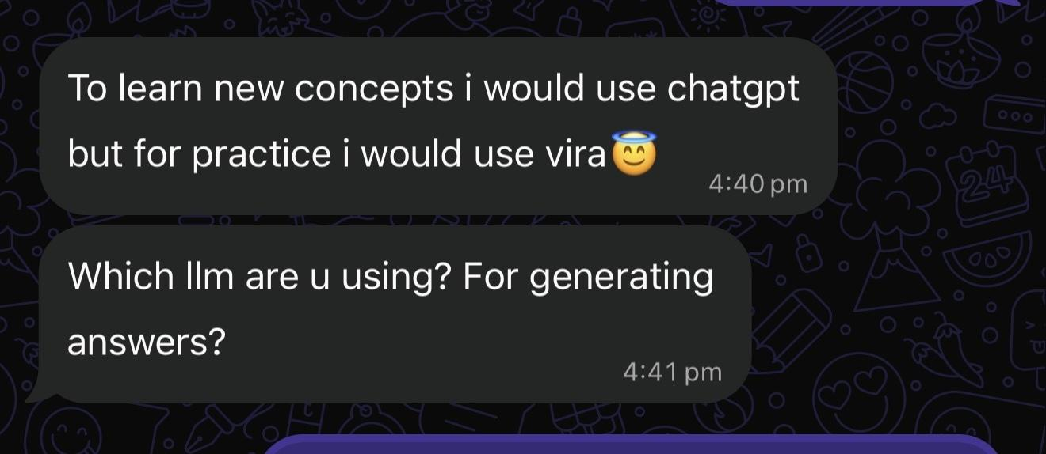
Figure 1. Tester preference for Vira as a practice environment.
Finding 2 — Users valued focused mentoring
“Working on one thing at a time also makes the advice easier to follow.”
Insight: A tester appreciated the clean design, step-by-step flow, guest access, realistic situations and focused guidance.
Product decision: Keep one high-priority improvement visible, with detailed analysis available on demand.
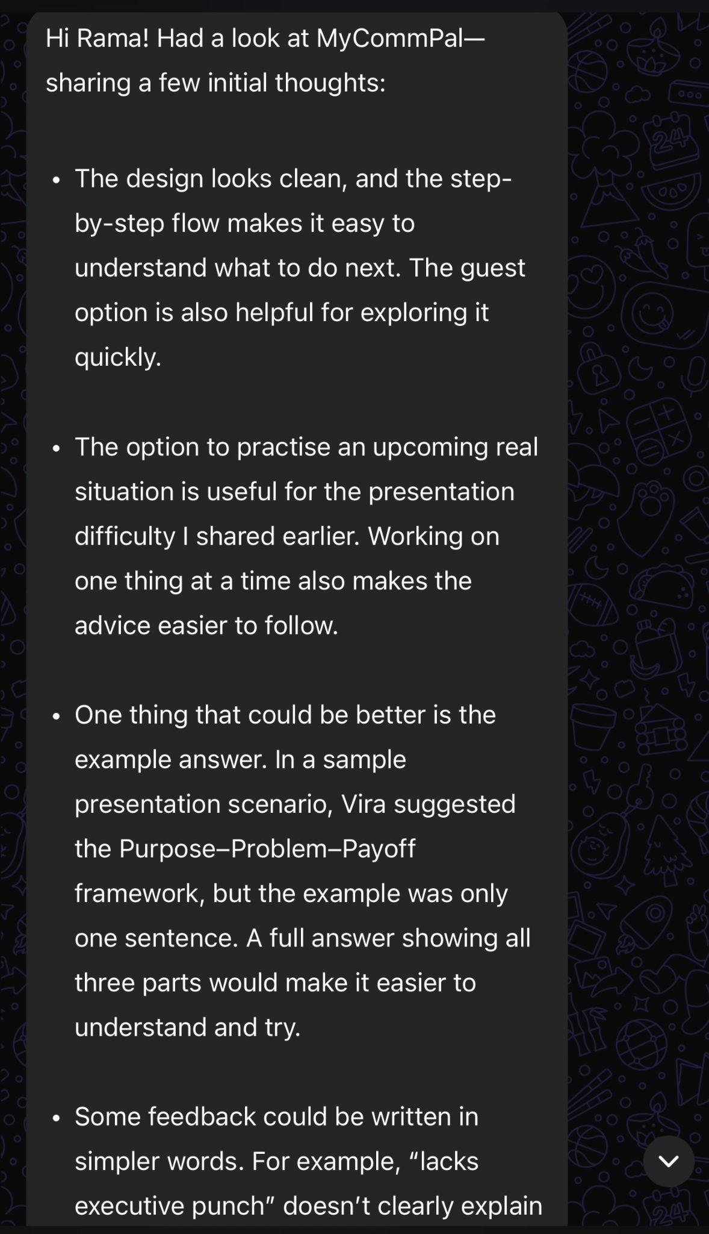
Figure 2. Feedback on the guided mentoring experience.

Finding 3 — Learning support must be discoverable
“No i couldn't find it.”
Insight: A tester wanted reference concepts before practicing but could not locate the Deep Dive framework content.
Product decision: Deep dive view kept as a separate tab intentionally to reduce cognitive load for users due to lot of upfront information
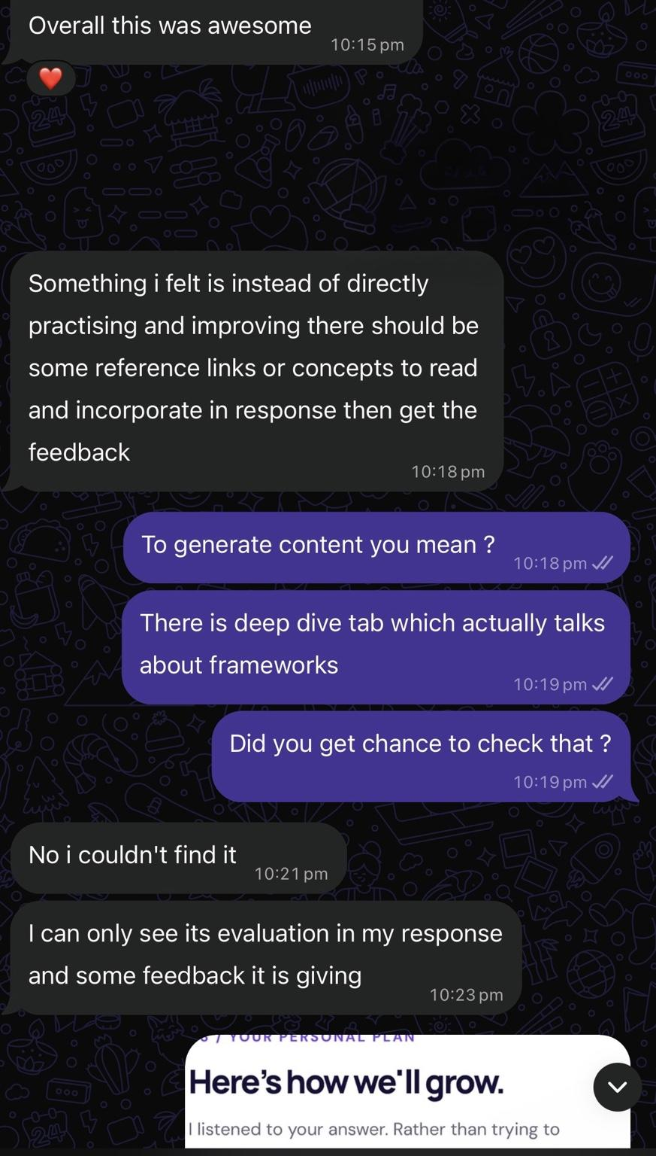
Figure 3. A tester could not find framework guidance.
Finding 4 — Voice input and assessment reliability
“Speech to text is typing multiple times.”
Insight: One tester reported duplicated transcription, more than 3,000 captured characters and an unavailable feedback action.
Product decision: Verify transcription deduplication and form-state validation across mobile browsers.
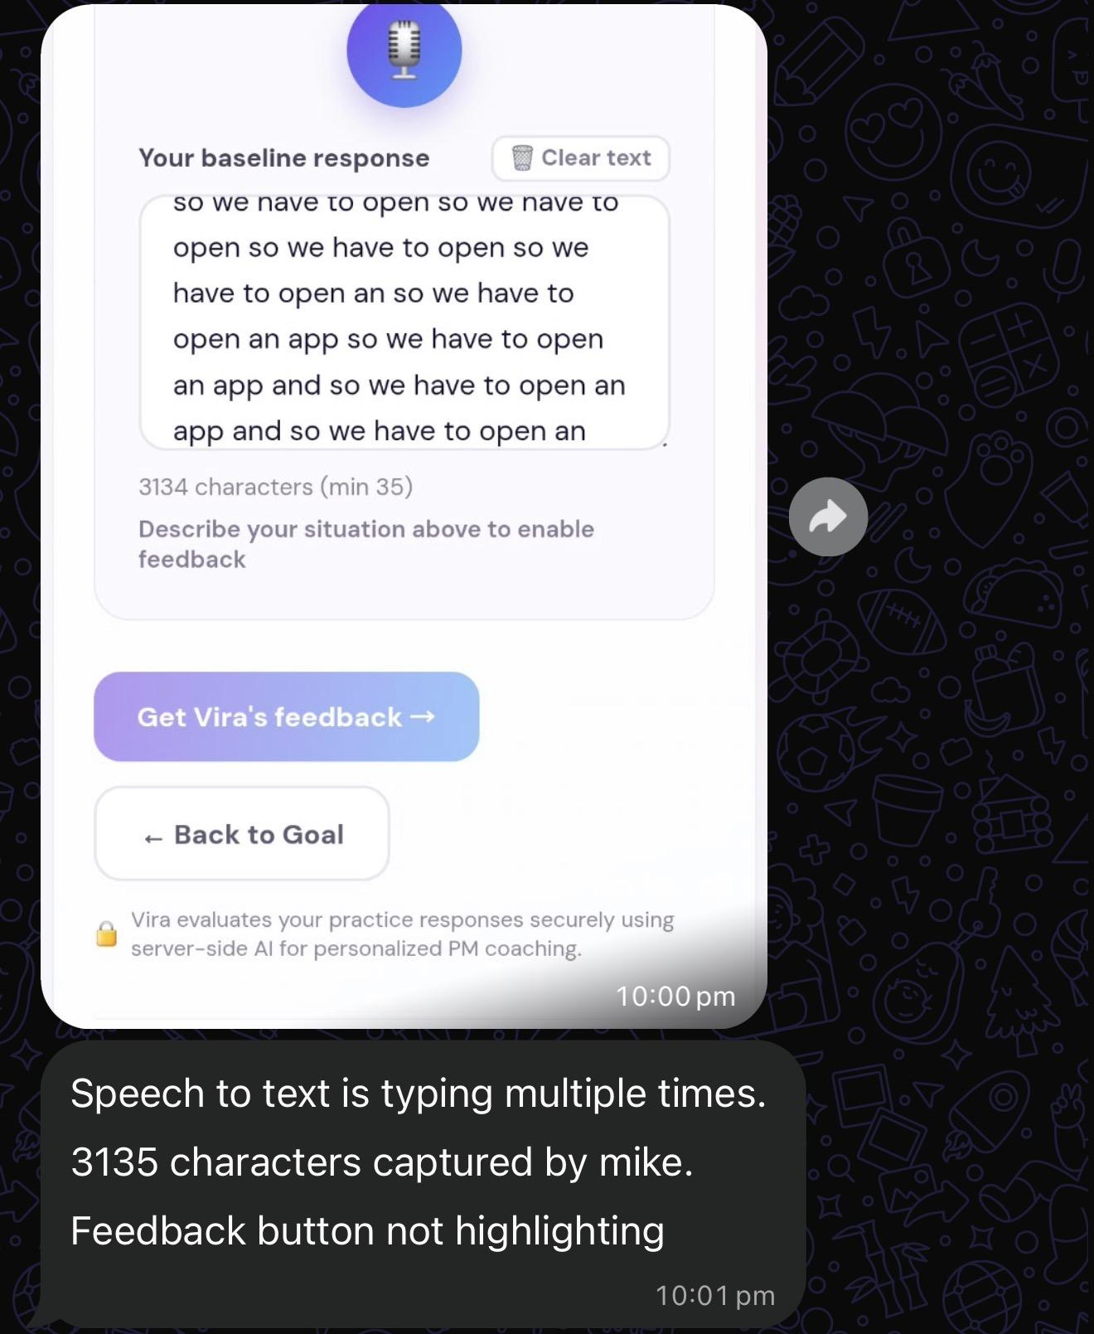
Figure 4. Repeated transcription and blocked feedback submission.

Finding 5 — Progress accuracy and workflow clarity

“Streak shows 1 day … [but] ‘No completed practice session yet’.”
Insight: A tester reported conflicting progress indicators, unclear disabled steps and repeated microphone text, despite positive comments about the AI mentor.
Product decision: Ensure streaks reflect completed sessions and explain why subsequent journey steps are unavailable.
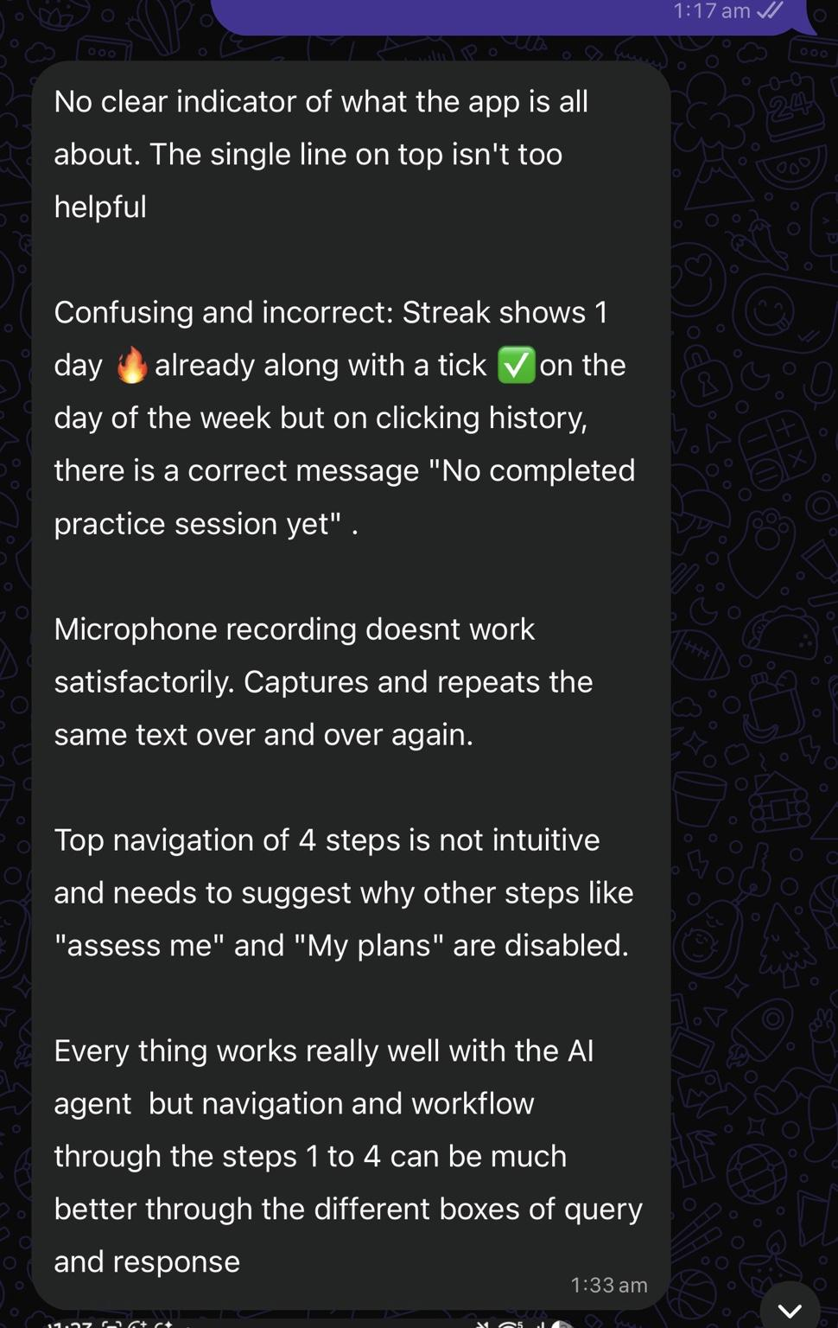
Figure 5. Inconsistent progress indicators and unclear navigation.

10.3 Key Insights & Product Decisions

Insight | Product Decision | Priority
Guided practice has perceived value | Retain targeted mentoring and immediate retry | Core Product
Frameworks and examples can be difficult to find | No fix. This was intentional to keep cognitive load minimal for users. | N/A
Voice and workflow defects can block completion | Retest speech capture, validation, retry, and comparisons | P0 — validate
Progress information must be trustworthy | Align streaks and history with completed sessions | P0 — validate
Some users want deeper explanations | Offer worked examples and optional deeper guidance | P1
Some users want reasons to return | Explore session history, progress and reminders | Future
These are feedback-driven decisions. Implementation status and retest outcomes should be documented separately.

10.4 What the Feedback Validates
- Early positive signals: users appreciate focused mentoring, realistic practice, concise feedback and low-friction entry. The direct comparison quote provides a qualitative signal that some users see Vira as a dedicated practice experience.
- Outstanding evidence: independent before/after articulation ratings, transfer to new scenarios, repeat use, willingness to pay, and controlled head-to-head comparisons with alternatives.

10.6 Key Product Learning
Users value personalized guidance, but it only helps when the practice journey works reliably and the recommended learning is easy to discover and apply.
Next step: verify which issues have been fixed in the latest version and retest them with users. Do not mark historical feedback items “resolved” until the corresponding production behavior is confirmed.
Evidence note: Screenshots are provided by early testers. Quotes are verbatim excerpts; findings are qualitative, and the images may represent different application versions.

11. Go-to-Market & Adoption Strategy

11.1 Target Audience
MyCommPal will initially target working Product Managers who want to improve how they articulate product ideas, recommendations, and decisions during stakeholder conversations.
Primary users: Product Managers, Senior PMs, and Lead PMs preparing for roadmap reviews, prioritization discussions, executive presentations, and challenging stakeholder conversations.
Future expansion: Aspiring PMs, people managers, and other professionals seeking communication development.

11.2 Positioning & Differentiation
MyCommPal — Your Personal AI Communication Mentor
Positioning: Before Product Managers can influence stakeholders, they need to articulate their product thinking clearly.
Unlike general-purpose AI assistants, MyCommPal offers a structured mentoring journey that helps users:
- Identify specific communication gaps.
- Understand weaknesses in decision reasoning, evidence, trade-offs, and impact.
- Learn a relevant communication technique.
- Practice and evaluate improvement.
Core value proposition: Don't just get a better answer. Become a better communicator.
Early validation signal:
"To learn new concepts I would use ChatGPT, but for practice I would use Vira."
This user feedback suggests an opportunity to differentiate MyCommPal through deliberate practice rather than general-purpose knowledge generation.

11.3 User Acquisition Strategy
MyCommPal will initially use low-cost, community-led distribution.

Channel | Acquisition Approach
Professional network | Invite working PMs to test MyCommPal using real communication challenges
LinkedIn | Share PM communication insights, product learnings, and MyCommPal demonstrations
PM communities | Introduce Vira through relevant WhatsApp groups, PM cohorts, and professional communities
Peer referrals | Encourage users who find the mentoring useful to share MyCommPal with colleagues
Mentoring networks | Explore partnerships with PM mentors and professional learning communities
Initial objective: Recruit 10–20 Product Managers for structured product testing before expanding distribution.
Initial cohort (10 named Product Managers): Bhavana, Vivek, Srikanth, Naresh, Santosh (colleagues); Charith, Manav, Nikhil, Chinmay (HelloPM cohort members); Ratan (friend).
These are the first 10 users identified for the GTM cohort. Individual practice completion, testing feedback, retention, and conversion must be tracked separately; the cohort list is not evidence that all 10 completed validation.

11.4 Activation Strategy
The goal is to help first-time users experience Vira's value with minimal effort.
Activation journey:
Discover → Start as Guest → Select Goal → Assess → Receive Guidance → Practice Again
Key activation enablers:
- Guest access without mandatory registration.
- Realistic PM scenarios and custom situations.
- Text and voice-based responses.
- Focused, actionable mentoring.
- Immediate opportunity to apply the recommended technique.
Activation event: A user completes their first assessment, receives personalized guidance, and makes at least one practice attempt.

11.5 Retention & Engagement Strategy
MyCommPal's retention strategy will focus on helping PMs prepare for real communication moments, rather than encouraging activity without a clear purpose.

Retention Opportunity | Strategy
Upcoming stakeholder conversations | Encourage practice before roadmap reviews, executive meetings, or presentations
Visible improvement | Show baseline-to-retry progress and areas requiring further development
Session history | Help users revisit previous practice and mentoring guidance
Personalized development | Recommend future exercises based on recurring communication gaps
Habit formation | Explore practice reminders and streaks after validating user demand
Early user feedback identified practice history, progress tracking, and reminders as potential reasons to return.
Retention hypothesis: PMs are more likely to return when MyCommPal helps them prepare for an upcoming real-world conversation.

11.6 GTM Success Metrics

Metric | What It Measures | Initial Target
User acquisition | Number of PMs participating in initial testing | 10–20 PMs
Activation rate | Percentage completing their first assessment and practice attempt | ≥70%
Practice completion | Percentage completing the full mentoring journey | ≥70%
Perceived usefulness | Users rating Vira's guidance at least 4/5 | ≥80%
Repeat usage | Users returning for another practice session within 14 days | ≥30%
Referral intent | Users willing to recommend MyCommPal to another PM | ≥60%
These are proposed pilot targets, not achieved results. Actual outcomes will guide subsequent product and GTM decisions.

11.7 Initial Rollout Plan

Phase | Focus | Expected Outcome
Phase 1 — Early Validation | Test with 10–20 PMs, collect feedback, and measure articulation improvement | Validate usefulness and identify critical friction
Phase 2 — Experience Refinement | Improve reliability, mentoring guidance, onboarding, and practice continuity | Increase successful practice completion
Phase 3 — Community Launch | Share through LinkedIn, PM communities, and referrals | Expand acquisition and validate repeat usage
Phase 4 — Commercial Validation | Explore individual subscriptions and organizational learning use cases | Validate willingness to pay

11.8 GTM Success Definition
MyCommPal's initial GTM succeeds when Product Managers discover the product, complete a meaningful mentoring journey, recognize improvement in their communication, and choose to return for future practice.
The initial priority is not rapid user acquisition or monetization.
It is to establish a repeatable cycle:
Acquire → Activate → Deliver Value → Improve → Retain → Refer
GTM philosophy: Build trust through demonstrable improvement, not through AI novelty.
MyCommPal aims to become the personal AI communication mentor Product Managers turn to before important conversations.

12. Risks, Limitations & Future Roadmap

12.1 Key Risks & Mitigation
Risk | Potential Impact | Mitigation
AI assessment inconsistency | Inaccurate or subjective communication scores | Defined rubrics, regression tests, and independent human validation
AI-generated misinformation | Misleading recommendations or invented business evidence | Ground feedback in user responses; distinguish facts from assumptions
Voice transcription errors | Incorrect assessment of users' communication | Improve speech-to-text reliability and allow transcript correction
Workflow friction | Users abandon practice before completing the journey | Simplify navigation, improve validation messages, and resolve reported issues
Data privacy | Exposure of sensitive workplace discussions | Secure backend APIs, access controls, and minimal data collection
Limited differentiation | Users prefer ChatGPT or established communication platforms | Strengthen PM Decision Communication Intelligence and validate comparative value
Low repeat usage | Users do not develop sustained practice habits | Test event-driven practice, progress tracking, and personalized guidance

12.2 Current MVP Limitations

Limitation / Area | Description
AI Assessment Scores | AI-generated scores are developmental indicators, not independently validated measures of communication ability.
Same-Scenario Retry | Improvement on the same scenario may reflect familiarity rather than transferable skill development.
Focus Scope | The MVP focuses on articulation, not comprehensive stakeholder influence or negotiation.
Interaction Capabilities | Real-time conversational mentoring and advanced voice interaction are outside the current scope.
Long-Term Outcomes | Long-term effectiveness, retention, and willingness to pay remain unvalidated.

12.3 Future Product Roadmap

Priority | Capability | Expected Value
P0 — Stabilize | Resolve voice, navigation, session continuity, and scoring issues identified during testing | Reliable end-to-end mentoring
P1 — Strengthen Mentoring | Clearer framework examples, before-and-after explanations, and follow-up clarification questions | More actionable learning
P1 — Validate Improvement | Independent assessments and unfamiliar-scenario practice | Evidence of genuine skill development
P2 — Personalize | Communication blind-spot profiles, progress history, and tailored exercises | Sustained skill improvement
P2 — Deepen Practice | Adaptive stakeholder challenges and conversational mentoring | Better preparation for difficult conversations
Future — Expand | Additional professional personas, enterprise learning, and integrations | Broader adoption and commercial opportunities
Roadmap priorities reflect user feedback and product hypotheses. Proposed enhancements are not presented as completed features.

12.4 Product Trade-offs
MyCommPal deliberately prioritizes articulation-first mentoring over building a comprehensive communication training platform.
This means:
- Depth over breadth: Improve product decision articulation before expanding into broader communication skills.
- Learning over answer generation: Help users develop their own responses rather than depend on AI-written answers.
- Reliability over features: Address core user-experience issues before introducing advanced capabilities.
- Evidence over assumptions: Validate measurable improvement before scaling or monetizing.

12.5 Strategic Direction
MyCommPal's long-term vision is to become a trusted personal AI communication mentor that grows with users throughout their professional journeys.
The immediate priority is to validate that Vira can help Product Managers consistently improve how they articulate decisions, reasoning, and trade-offs.
Our product principle: Strengthen the foundational communication skill first. Build broader influence and leadership capabilities on top of it.

13. Key Learnings & Conclusion

13.1 Key Product Learnings
Building MyCommPal reinforced five important Product Management lessons:

Learning | Key Takeaway
Start with a real problem | AI creates value when applied to a validated customer pain point, not simply because the technology exists.
Solve the foundational problem first | Clear articulation is essential for communicating product decisions, influencing stakeholders, and handling difficult conversations.
Focus creates differentiation | MyCommPal's value lies in PM-specific mentoring, targeted techniques, and guided improvement—not the underlying LLM.
User feedback drives better products | Early testing validated interest in guided practice while revealing opportunities to improve reliability, usability, and mentoring guidance.
Measure outcomes, not features | Success is demonstrated when users improve their communication, not merely when AI generates feedback or scores.

13.2 What We Built
MyCommPal — Your Personal AI Communication Mentor
We built Vira, an AI mentor designed to help Product Managers:
- Identify gaps in their communication.
- Understand weaknesses in decision clarity, evidence, trade-offs, and impact.
- Learn personalized communication techniques.
- Practice realistic situations and assess improvement.
The MVP delivers a focused journey:
Understand → Diagnose → Guide → Practice → Reflect

13.3 Early Validation & Next Steps
Early user feedback indicates that Product Managers and other testers value personalized guidance, realistic scenarios, and structured practice.
One user summarized MyCommPal's potential differentiation:
"To learn new concepts I would use ChatGPT, but for practice I would use Vira."
However, measurable skill improvement, sustained usage, and superiority over existing alternatives still require structured validation.
Next priorities:
- Resolve critical usability and reliability issues.
- Validate articulation improvement through independent assessments.
- Test learning transfer to unfamiliar scenarios.
- Measure repeat usage and willingness to pay.

13.4 Conclusion
Product Managers don't always struggle because they lack good ideas. Sometimes, they struggle because their ideas aren't communicated clearly enough.
MyCommPal addresses this foundational gap by helping PMs turn product thinking into clear, structured, and defensible communication.
Our ambition is not to replace human communication with AI, but to use AI to strengthen human communication skills.
The product philosophy: Don't just get a better answer. Become a better communicator.

14. AARRR Growth & Monetization Strategy

14.1 Growth Objective
MyCommPal's growth strategy focuses on helping Product Managers experience the value of personalized AI mentoring, return for real communication challenges, and recommend the product to peers.
The AARRR framework defines how we plan to acquire, activate, retain, and monetize users.

14.2 AARRR Growth Framework

Stage | MyCommPal Strategy | Success Metric
Acquisition | Acquire the first 10 working PMs through professional networks, LinkedIn, and PM WhatsApp communities. | 10 PMs start their first session
Activation | Within 2 minutes, Vira identifies one specific articulation gap and recommends an actionable technique. | Users receive and understand their first personalized insight
Retention | PMs return before important stakeholder meetings, roadmap reviews, or presentations to practice and improve. | Users completing another session within 14 days
Referral | Users who experience valuable mentoring recommend MyCommPal to colleagues facing similar communication challenges. | New users acquired through referrals
Revenue | Offer free introductory practice and paid access to extended mentoring, additional sessions, and progress insights. | Free-to-paid conversion rate

14.3 Key Growth Moments
Aha Moment — Activation
"Vira identified a communication weakness I hadn't noticed and showed me exactly how to improve."
This is the first meaningful value users should experience, ideally within two minutes.
Return Trigger — Retention
"I have an important stakeholder conversation coming up. Let me practice with Vira first."
MyCommPal will initially prioritize event-driven retention over daily engagement.
Sharing Moment — Referral
"I practiced with Vira and improved how I explained my decision. You should try it before your next stakeholder meeting."
Referrals should follow a meaningful mentoring experience rather than interrupt the practice journey.

14.4 Monetization Hypothesis
Primary paying customer: Individual Product Managers seeking ongoing communication development.
Proposed business model: Freemium subscription.
- Free: Limited introductory mentoring and practice sessions.
- Premium: Additional practice, personalized development guidance, and progress insights.
- Future B2B: Team subscriptions for Product Management organizations and professional learning programs.
Pricing and willingness to pay remain unvalidated.

14.5 Growth Success Definition
North Star Metric: Number of users completing a meaningful mentoring cycle—baseline assessment, personalized guidance, and at least one practice retry.
Growth hypothesis: PMs who experience actionable mentoring and observable communication improvement are more likely to return for future workplace challenges and recommend MyCommPal.
Current validation status: Early qualitative feedback indicates interest in guided communication practice. Activation, retention, referral, and monetization outcomes require further testing.
Growth philosophy: Deliver meaningful improvement first. Let adoption and revenue follow demonstrated user value.

